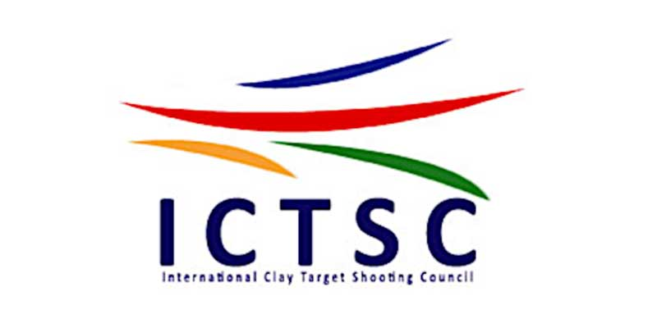

Statement for the forthcoming Home Internationals 2020

Dublin, 3rd April 2020

Dear Fellow Shooter,

It is with regret that we the ICTSC committee have to inform you of the postponement of the 2020 Home Internationals, as you will appreciate the Covid-19 situation makes it difficult to plan for anything such as selection shoots, Hotels, Banquets, flights and ferries. Thus we have taken the unprecedented decision of pushing back the season to 2021. This means that the Grounds and Country’s that were due to hold shoots in 2020 will now hold them in 2021 on the pre allocated weekends as per the ICTSC rota.

Stay indoors, stay safe,

Yours in sport

Erig Conway

Chairman ICTSC

